1. Pad A Comfortable Electrocutaneous-based Tactile Feedback Display

【Main Content】:

A novel electrocutaneous-based tactile device with the name of E-pad is pro-posed to provide a dynamic and static low-voltage feedback for touchscreen. We optimize the key parameters of the output voltage and design custom-made hardwares to guarantee a comfortable user experience. Users could move their fingers freely across the touchscreen of the proposed device to really feel virtual objects.

(The E-Pad's design focuses on enhancing the feedback and comfort of the tactile display on the touch screen without significantly increasing its cost and complexity.)

【Contribute】：

• We developed a feedback platform to achieve low-voltage electrical stimulation tactile feedback, and verified the feasibility of electrocutaneous feedback;

• We evaluated the electrocutaneous tactile technique by steering task based on Fitts’ Law, which proved that the deficiency of the prior could be compensated by the electric stimulation technique.

【E-PAD Design】：

1. Mechanism
2. Definition of E-Pad System

The electronic pen can extract texture data from the displayed image and provide tactile feedback to the finger. The proposed device is divided into two parts: a control unit in which the haptic stimulus is generated and adjusted, and a display unit that displays an image and sends rendered data of the image texture to the control unit. The display unit is composed of a mobile computer and an infrared touch screen, which is composed of a transparent electrode sheet (ITO) applied on a glass substrate.

When the E-Pad is booted up, user could choose the image displayed on screen, then the display unit drives the PC display to show the corresponding image on the screen and begins to gather data of finger position via infrared touch frame. The relevant rendering data of tactile information will be sent to the control unit when the user’s finger touches the screen. The electrocutaneous stimulation is produced by the control unit according to the rendering data and fed back to the finger.

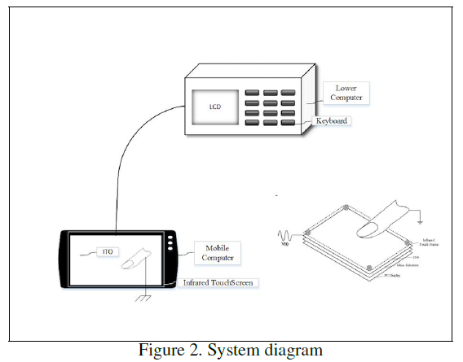 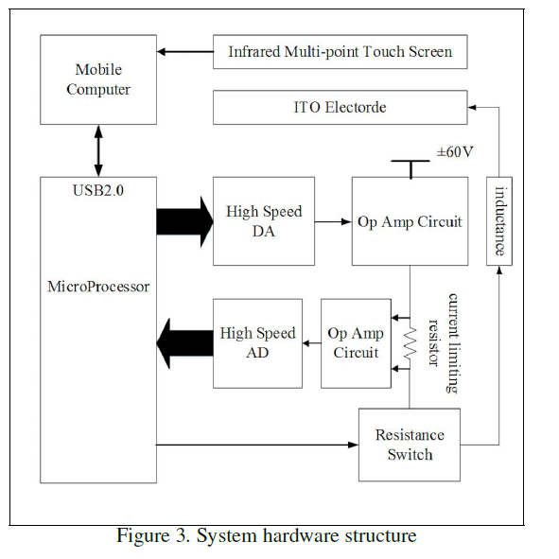

[The hardware part omitted, detail in the parper]

【Experiments】：

**Experiment 1:** The E-Pad provided tactile feedback that couldn’t be normally experienced in everyday life, thus user study was conducted to understand how users perceives the tactile sensations produced by E-Pad. The fixed waveforms and pulse frequents were chosen to obtain the sensation threshold.

Results:

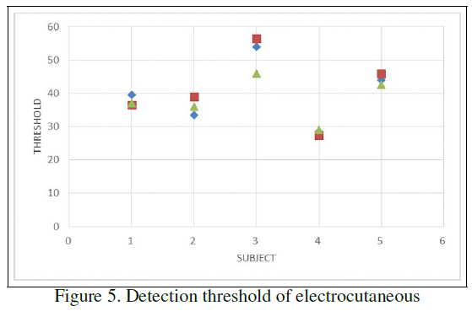 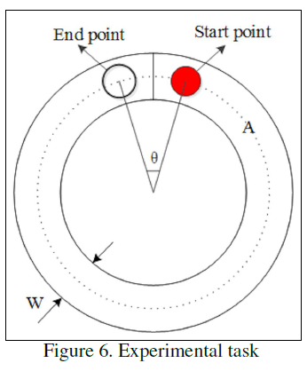 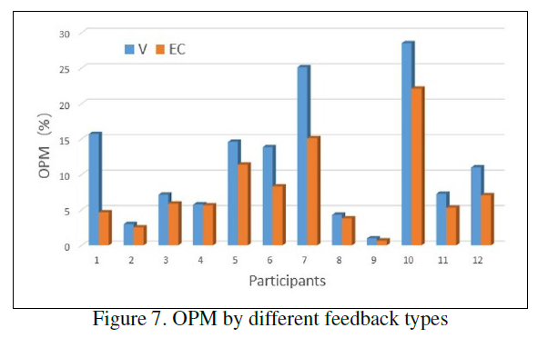

**Experiment 2:** we designed a new experiment and evaluated the interactive effect. Experiments were conducted to compare the electrical stimulation with the vibration as a typical feedback technique by designing a special steering task.

Record:

1. Feedback technology can reduce task time;
2. Compared with vibration technology, electric feedback technology can effectively improve accuracy;

Results:

(1) Out of Path Movement(OPM)->EC:7.71％ ->V:11.44％

(2) Since the OPM varies greatly between different users, the formula below is used to calculate the ratio of personal accuracy improvement



The results showed that the electro-tactile feedback can improve the accuracy of the touch-screen basic operation such as click and slide, etc.. On the side, the different users had obvious distinction in the sensitivity of the electrical tactile sensation.

Standard Deviation（SD）: The SD data for Experiment 2 was shown in Fig.9. The SD of electrocutaneous condition was,on average, 15.94, comparing to 17.73 of the vibration condition.

Movement Time（MT）：The participants proformed the task no significantly faster on electro-cutaneous feedback than on vibration feedback.

